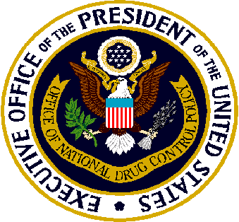

High Intensity Drug Trafficking Areas (HIDTA)
Process for Designation – An Overview
Background: High Intensity Drug Trafficking Areas (HIDTA) include specified regions in 49 states, the District of Columbia, Puerto Rico, and the U.S. Virgin Islands. To join the HIDTA Program, new areas must be designated by the Director of the Office of National Drug Control Policy (ONDCP).
Eligibility for Designation: To be considered for designation, evidence must be provided to demonstrate the following:
- The area is a significant center of illegal drug production, manufacturing, importation, or distribution;
- State, local, and tribal law enforcement agencies have committed resources to respond to the drug trafficking problem in the area, thereby indicating a determination to respond aggressively to the problem;
- Drug-related activities in the area are having a significant, harmful impact in the area and in other areas of the United States; and
- A significant increase in Federal resources is necessary to respond adequately to drug-related activities in the area.
Who May Seek Designation: Petitions must be submitted by a coalition of law enforcement agencies from the geographic area seeking HIDTA designation.
Petitions for HIDTA Designation must:
- Specify the geographic area for which HIDTA designation is being sought. (Areas typically are designated by county and/or city.)
- Include an assessment of the threat posed by illicit drugs in the area. (The assessment must specifically address each of the four points listed in the Eligibility for Designation section above.)
- Include individual and separate submissions for each geographic area for which HIDTA designation is sought. (For example, if designation is sought for multiple adjacent counties, a separate petition must be submitted for each county.)
- Receive the approval of the Executive Board of the regional HIDTA program to which, if the petition is successful, the area would be added.

Who Determines Which Areas are Designated: ONDCP staff convenes a panel of independent law enforcement experts, which includes a representative from the HIDTA Directors Committee, to review petitions for HIDTA designation. The panel evaluates the petitions and recommends for designation those submissions that meet the requirements listed in the Eligibility for Designation section above. These recommendations are provided to the Director of ONDCP, who determines which petitions should receive HIDTA designation.
After the ONDCP Director determines which areas should receive HIDTA designation, ONDCP consults with Cabinet secretaries, the heads of national drug control agencies, and the governors of those states with areas slated for designation. After that consultation is complete, ONDCP posts notice of the designation in the Federal Register, notifies Congressional delegations, and publicly announces the addition of new areas to the HIDTA Program.
When Are Areas Designated: Petitions for designation will be reviewed, at a minimum, annually in the Spring. ONDCP will establish a deadline for submission of petitions, and will notify HIDTA directors at least 60 days in advance.
Letters of Support: Letters of support from Members of Congress, governors, and others are not required. Letters may be submitted in conjunction with petitions for designation; however, only the petitions themselves are provided to the panel of independent law enforcement experts for review.
Funding for Newly Designated Areas: Areas that receive HIDTA designation often receive, but are not guaranteed, additional funding. Funding determinations for newly designated areas are made separately from the designation process itself, and are based upon availability and demonstrated need.
Additional Resources: Additional information about the designation process can be found in the ONDCP Reauthorization Act of 2006 (Public Law 109-469 [2006]) and in Federal Register Volume 72, Number 158 (August 2007). Inquiries also may be directed to ONDCP via e-mail ONDCP_HIDTA@ondcp.eop.gov .

April 18, 2018

